# Aim

* To test the accuracy and reliability of the split-core current sensor

# Equipment

* Laboratory autotransformer (aka. A variac)
* Load bank (60W bulb bank)
* In-line current meter
* Split core current sensor + connected data logger

# Method

## Circuit

* A burden resistor of 220 Ohms was used to provide a readable current range of 0-10A
* A rail-to-rail op amp was used to clip voltages that occur as a result of currents that are out of that range
  + This protects the data logger against over-voltage damage

## Testing

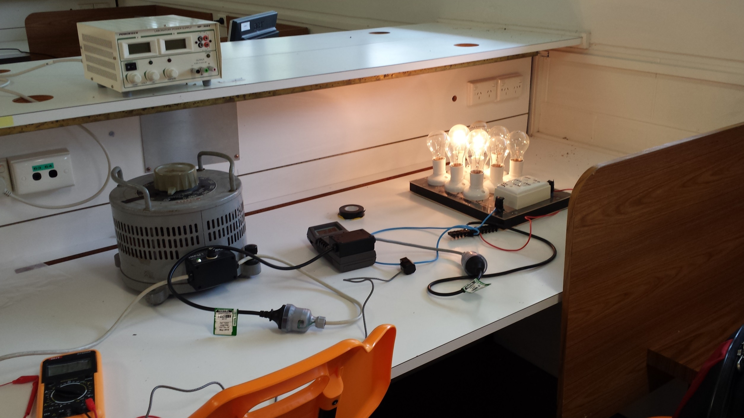

* The autotransformer supplies power to the load bank
  + The lab current meter sits in-line with the supply cabling
  + The current sensor is clamped around a single supply wire
* The voltage on the autotransformer, and number of active bulbs on the load bank was varied to produce the desired current
  + Current is read off the lab current meter to set the level
  + After changing the current, the data logger is given a few seconds to stabilise, then the value is recorded
  + Variance of the readings in subsequent samples were also observed
* Supply voltage from the autotransformer was not allowed to go above 50V for safety reasons

# Results

|  |  |  |  |
| --- | --- | --- | --- |
| Meter Current (A) | Measured Current (A) | Error (abs) | Error (rel) |
| 0.32 | 0.32 | 0.00 | 0.00% |
| 0.41 | 0.41 | 0.00 | 0.00% |
| 0.51 | 0.51 | 0.00 | 0.00% |
| 0.71 | 0.71 | 0.00 | 0.00% |
| 0.81 | 0.81 | 0.00 | 0.00% |
| 0.90 | 0.91 | 0.01 | 1.11% |
| 1.00 | 1.00 | 0.00 | 0.00% |
| 1.04 | 1.05 | 0.01 | 0.96% |
| 1.33 | 1.33 | 0.00 | 0.00% |
| 1.49 | 1.49 | 0.00 | 0.00% |
| 1.74 | 1.74 | 0.00 | 0.00% |
| 2.02 | 2.03 | 0.01 | 0.50% |
| 2.52 | 2.53 | 0.01 | 0.40% |
| 3.02 | 3.01 | -0.01 | -0.33% |
| 3.49 | 3.46 | -0.03 | -0.86% |
| 4.00 | 3.97 | -0.03 | -0.75% |
| 4.51 | 4.47 | -0.04 | -0.89% |
| 5.00 | 4.99 | -0.01 | -0.20% |
| 6.06 | 6.04 | -0.02 | -0.33% |
| 7.01 | 6.97 | -0.04 | -0.57% |
| 8.04 | 8.01 | -0.03 | -0.37% |
| 9.03 | 9.01 | -0.02 | -0.22% |
| 10.14 | 10.06 | -0.08 | -0.79% |
| 11.03 | 10.85 | -0.18 | -1.63% |
| 12.05 | 11.38 | -0.67 | -5.56% |
| 12.78 | 11.68 | -1.10 | -8.61% |

* Throughout the current range, the variance of the recorded current was $±0.025 A$
* Similarly, the variance of the lab current meter was approximately $±0.01 A$
* Below 3A, the variance of the current sensor is greater than the difference between the lab meter readings and the measured temperature through the current sensor
* Above 10A, error increases

# Discussion

* Errors above the 10A mark are likely due to voltage clipping of the current waveforma
* Part of the waveform still exists, meaning the calculated current can be higher than 10A

# Conclusion

* The meter is most accurate below 3A, where it has an accuracy of $±25 mA$